Name: ______________________________________ Date: ________________________

Student Exploration: Rabbit Population by Season

Vocabulary: carrying capacity, density-dependent limiting factor, density-independent limiting factor, limiting factor, population, population density

Prior Knowledge Questions (Do these BEFORE using the Gizmo.)

- Suppose you had a pet rabbit. What would the rabbit need to stay alive and healthy?

_________________________________________________________________________

_________________________________________________________________________

- A female rabbit can give birth to over 40 baby rabbits a year. Suppose all of her offspring survived and reproduced, all of their offspring survived and reproduced, and so on. If that happened, in only eight years the mass of rabbits would exceed the mass of Earth!

So, why aren’t we overrun with rabbits? What keeps the rabbit population in check?

_________________________________________________________________________

_________________________________________________________________________

_________________________________________________________________________

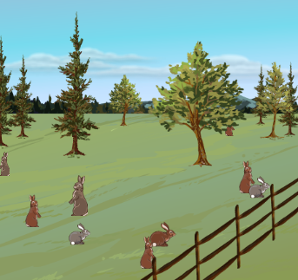
Gizmo Warm-up
A population is a group of individuals of the same species that live in the same area. The size of a population is determined by many factors. In the Rabbit Population by Season Gizmo, you will see how different factors influence how a rabbit population grows and changes.

- Select the BAR CHART tab. What is the size of the initial rabbit population? ______________

- Select the TABLE tab. Click Play (), and allow the simulation to run for one year.

- In which season did the rabbit population increase the most? __________________

- In which season did the rabbit population increase the least? __________________

Activity A:  Carrying capacity | Get the Gizmo ready:  - Click Reset (). | 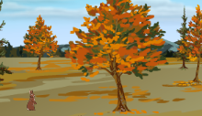

Question: What determines how large a population can grow?

- Think about it: A limiting factor is any factor that controls the growth of a population. What do you think are some of the limiting factors for the rabbit population? _________________
_________________________________________________________________________

_________________________________________________________________________

- Run Gizmo: Select the DESCRIPTION tab. Set the Simulation speed to Fast. Select the GRAPH tab. Click Play, and allow the simulation to run for at least 10 years. (Note: You can use the zoom controls on the right to see the whole graph.)

- Describe how the rabbit population changed over the course of 10 years.

___________________________________________________________________

___________________________________________________________________

- What pattern did you see repeated every year? _____________________________

___________________________________________________________________

___________________________________________________________________

- How could you explain this pattern? ______________________________________

___________________________________________________________________

___________________________________________________________________

- Analyze: The carrying capacity is the maximum number of individuals of a particular species that an environment can support. All environments have carrying capacities.

- What is this environment’s approximate carrying capacity for rabbits? (Note: Average the summer and winter carrying capacities.) ________________________________
- When did the rabbit population reach carrying capacity? Explain how you know.

___________________________________________________________________

___________________________________________________________________

Activity B:  Density-dependent limiting factors | Get the Gizmo ready:  - Click Reset.  - On the SIMULATION pane, make sure Ample is selected for the amount of LAND available. | 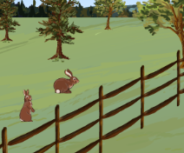

Introduction: Population density is the number of individuals in a population per unit of area. Some limiting factors only affect a population when its density reaches a certain level. These limiting factors are known as density-dependent limiting factors.

Question: How does a density-dependent limiting factor affect carrying capacity?

- Think about it: What do you think some density-dependent limiting factors might be? _________________________________________________________________________
_________________________________________________________________________

- Predict: Suppose a shopping mall is built near a rabbit warren, leaving less land available for rabbits. How will this affect the environment’s carrying capacity?

_________________________________________________________________________

- Experiment: Use the Gizmo to find the carrying capacity with Ample, Moderate, and Little land. List the carrying capacities below.

Ample: _________________ Moderate: _________________ Little: _________________

- Analyze: How did the amount of space available to the rabbits affect how many individuals the environment could support? _______________________________________________
_________________________________________________________________________

- Infer: Why do you think limiting a population’s space decreases the carrying capacity?

_________________________________________________________________________

_________________________________________________________________________

- Challenge yourself: Other than space, what might be another density-dependent limiting factor? Explain. ____________________________________________________________
_________________________________________________________________________

_________________________________________________________________________

Activity C:  Density-independent limiting factors | Get the Gizmo ready:  - Click Reset.  - On the SIMULATION pane, select Ample for the amount of LAND available. | 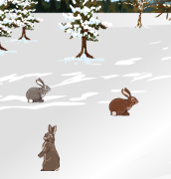

Introduction: Not all limiting factors are related to a population’s density. Density-independent limiting factors affect a population regardless of its size and density.

Question: How do density-independent limiting factors affect how a population grows?

- Think about it: What do you think some density-independent limiting factors might be? _________________________________________________________________________
_________________________________________________________________________

- Gather data: Click Play. Allow the population to reach carrying capacity. Click Pause (). Select the GRAPH tab and click the camera () to take a snapshot of the graph. Paste the snapshot into a blank document. Label the graph “Normal Weather.”

- Predict: How do you think a period of harsh winters will affect the rabbit population?

_________________________________________________________________________

_________________________________________________________________________

- Investigate: Click Reset. Select Harsh winter from the CONDITIONS listed on the SIMULATION pane. Click Play, and observe the how the population changes over five years. Paste a snapshot of the graph in your document. Label the graph “Harsh Winter.”

  - How does the Harsh Winter graph differ from the Normal Weather graph? ________

___________________________________________________________________

  - What do you think most likely caused the differences seen in the two graphs?

___________________________________________________________________

___________________________________________________________________

- Predict: Rabbits reproduce in the spring. How do you think a period of cold springs will affect the rabbit population? _______________________________________________________
_________________________________________________________________________

(Activity C continued on next page)
Activity C (continued from previous page)

- Investigate: Deselect Harsh winter. Select Cold spring. Click Play, and observe the how the population changes over a period of five years. Paste a snapshot of the graph in your document and label the graph “Cold Spring.”

- How does the Cold Spring graph differ from the Normal Weather graph? _________

___________________________________________________________________

- What do you think most likely caused the differences seen in the two graphs?

___________________________________________________________________

___________________________________________________________________

- Predict: How do you think a period of hot summers will affect the rabbit population?

_________________________________________________________________________

_________________________________________________________________________

- Investigate: Deselect Cold spring. Select Hot summer. Click Play, and observe the how the population changes over a period of five years. Paste a snapshot of the graph in your document. Label the graph “Hot Summer.”

- How does the Hot Summer graph differ from the Normal Weather graph? ________

___________________________________________________________________

- What do you think most likely caused the differences seen in the two graphs?

___________________________________________________________________

___________________________________________________________________

- Think and discuss: Other than unusual weather, what might be another density-independent limiting factor that could affect the rabbit population? If possible, discuss your answer with your classmates and teacher.

_________________________________________________________________________

_________________________________________________________________________

_________________________________________________________________________

_________________________________________________________________________

_________________________________________________________________________

