Process For ACT Science Training
1.do the whole science test with no tips
2.Do the test again with a passage at a time learning the tips and practice individual times for each passage
3.Do the whole test again using the tips just learned
4. test is 35 minutes long
5.Types of passages
-2 data representation
-3 research summaries
-1 conflicting viewpoints

Basic Tips
1.write in your booklet
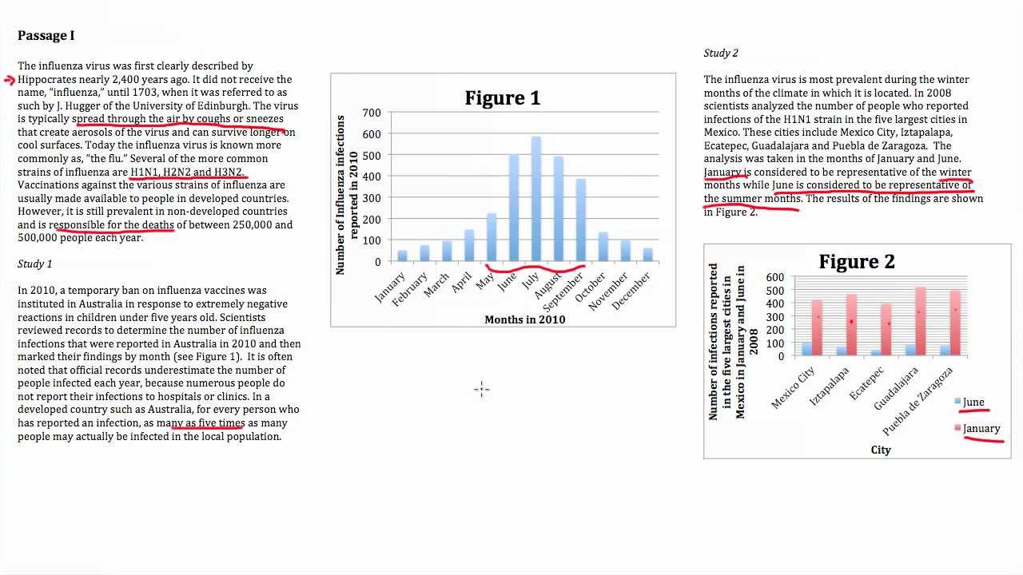
2.Fingers
-Use your fingers to keep your place because looking back and forth losing you place on the test will cost you time AND your eyes go where you are pointing
-In Data Representation/Research summary-you have to move around to tables , charts, and summaries
-find your table-put your finger on it and go back to the passage or question
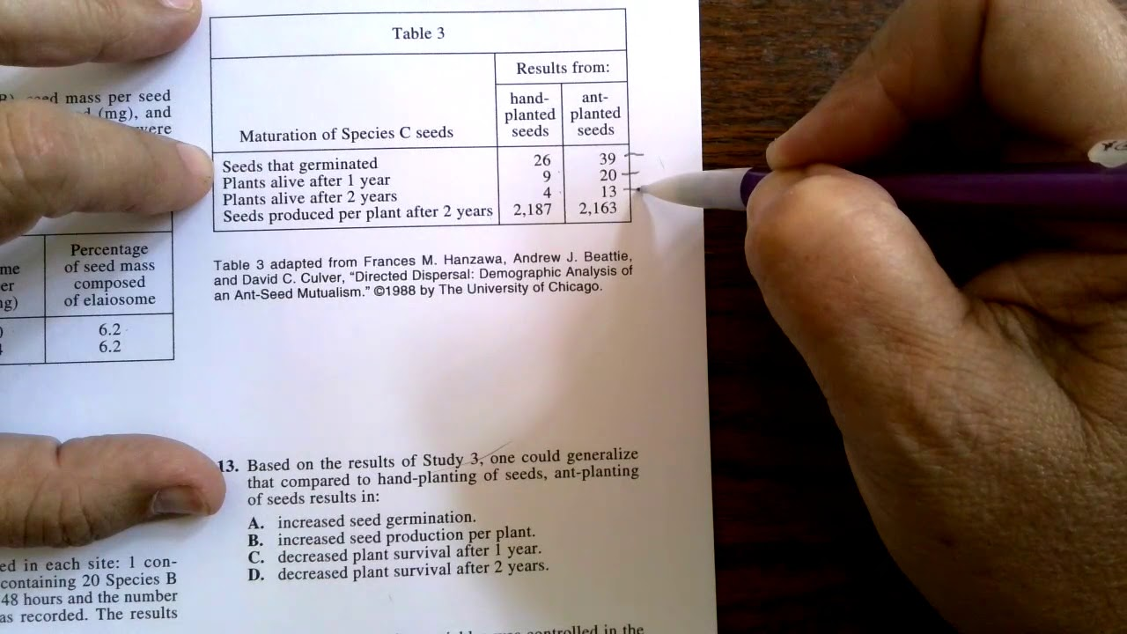

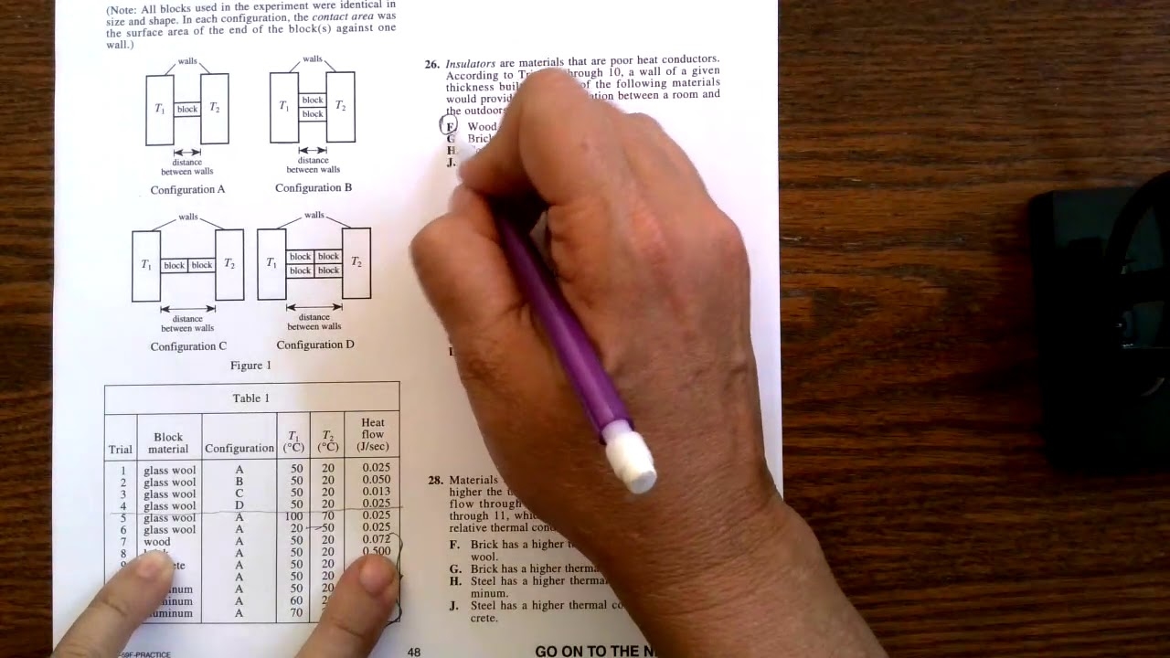
3.Record which strategies work for you
4.Don’t let language bog you down
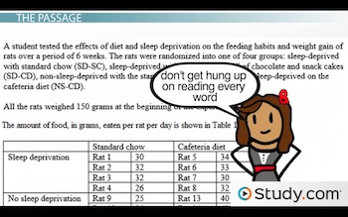
5.circle questions to go back to
6.use the process of elimination
7.Do not fill in the test sheet until you hear five minutes-you waste time going back and forth AND you increase your getting your answer numbers off

Basic Graphs and Tables
1.Look for relationships between data Direct vs Indirect
You can draw arrows in your book
Direct-variables go the same direction
Indirect-variables go in opposite direction
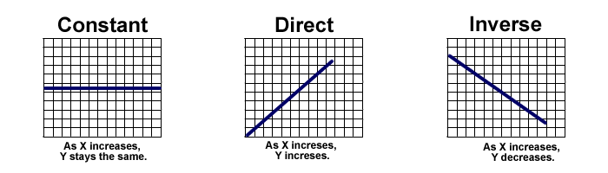
2.Look for data that is between data or off the chart
Extrapolation-draw a line and go above or below the data
Interpolation-data in question exists between data points
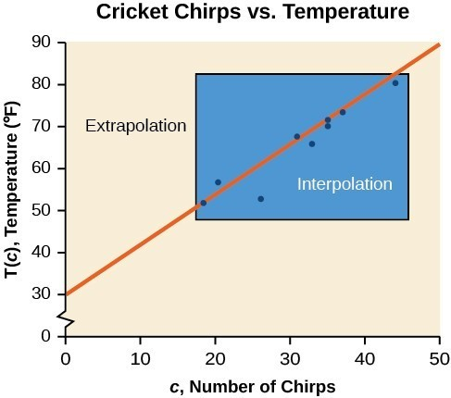
3.Look for LARGE changes in data
4.Tables
-What are the features, units, titles-
-How do the values change-do you want to mark them and draw arrows indicating relationships
-do you want to put information on the table

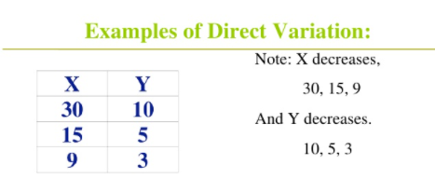
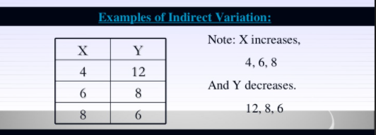

Extrapolation Table
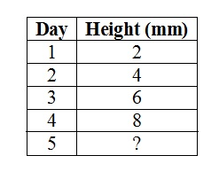
Interpolation Table-What is a good answer for day 4?
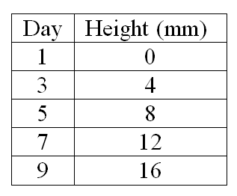
Gameplay to Manage Time
-Do not read questions blindly-cross off information you do not need
4 Minutes for each data representation
5 minutes each research summary
6 minutes or more at the end for conflicting viewpoints
LAST 5 Minutes to fill in answer sheet

Passages
1.Do conflicting view points LAST (6 minutes or more)
-toughest
-different in style to others
-spend more time on it at the end
-evaluates viewpoints/theories
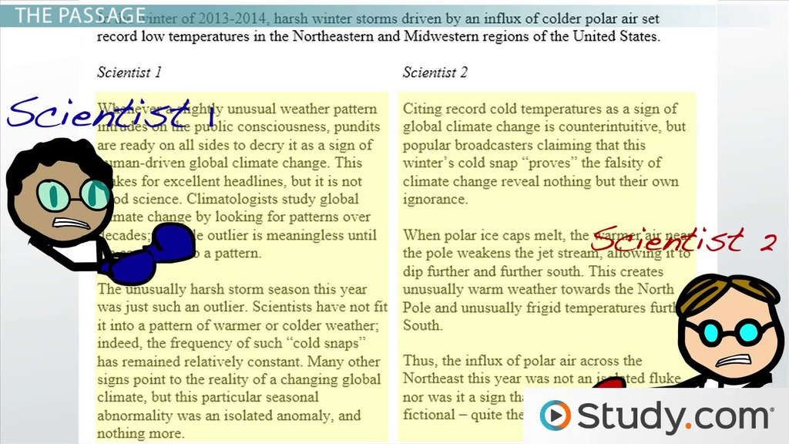
A.start with the questions and find the information from the charts or experiments
B.Put fingers by the charts or experiments you are working on
And Go back to the question to see what to look for
C.summarize s in plain language as you can make lists, use arrows on tables, or look for order

2.Data Representation (4 minutes each)
-read just enough to answer questions
-interpret information
-what is the basic topic and purpose of the experiments
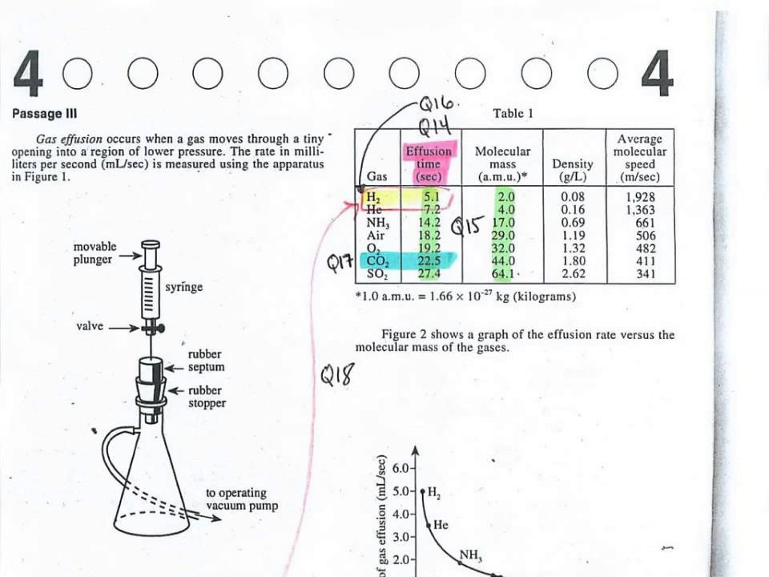
3.Research Summaries(Studies and Experiments)(5 minutes each)
-comparing experiments
-What is the basic topic and purpose of the experiment?

